Appendix O.
Financial Tables and ROI Analysis
Table O1.
Estimated Long-Acting PrEP Program Budget
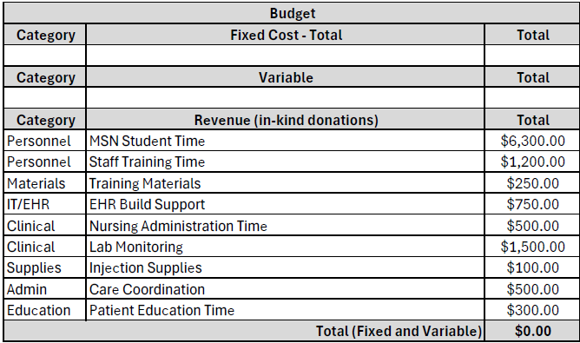

Figure O1.
Cost Avoidance Compared to Program Implementation Cost

Note. The estimated total implementation cost of the Yeztugo PrEP program is approximately $11,400, including personnel time, training, laboratory monitoring, and administrative support. Lifetime treatment cost for a single HIV infection is estimated at approximately $500,000 (Centers for Disease Control and Prevention [CDC], 2021; Farnham et al., 2013). The figure demonstrates that preventing even one HIV infection results in substantial net cost savings, with increasing financial benefit as additional infections are prevented. This analysis reflects implementation costs only and does not include medication expenses, which are typically covered through insurance or external funding mechanisms.

Table O2.
Return on Investment by Infections Prevented
Scenario | Infections Prevented | Net Savings ($) | ROI (%)
Minimal Impact | 1 | 488,600 | 4,286%
Moderate Impact | 2 | 988,600 | 8,672%
High Impact | 3 | 1,488,600 | 13,057%
Note. ROI was calculated by comparing estimated program implementation costs ($11,400) to lifetime HIV treatment costs of approximately $500,000 per infection (Centers for Disease Control and Prevention [CDC], 2021; Farnham et al., 2013). Even under conservative assumptions, preventing a single HIV infection yields a substantial return on investment, with ROI increasing significantly as additional infections are prevented. This analysis reflects implementation costs only and does not include medication expenses.

Figure O2.
Distribution of Long-Acting PrEP Program Implementation Costs

Note. The total estimated implementation cost of the Yeztugo PrEP program is $11,400. The largest proportion of costs is attributed to personnel time, particularly MSN student implementation effort, followed by laboratory monitoring and staff training. These costs reflect initial program development and operational setup and do not include medication expenses, which are typically covered through insurance or external funding sources.
Table O3.
Break-Even Analysis for Long-Acting PrEP Program
Program Cost ($) | Cost per HIV Infection ($) | Break-Even Point (Infections)
11,400 | 500,000 | 0.02

Note. Break-even point calculated by dividing total program cost ($11,400) by estimated lifetime HIV treatment cost ($500,000).

