Appendix I.
Implementation Tools and Operational Supports

Table I1.
Barriers and Mitigation Strategies
Barrier | Risk | Mitigation
Insurance delays | Delayed initiation | PA tracker/assistance programs
Missed appointments | Protection gaps | Reminder and outreach workflow
Staff turnover | Workflow inconsistency | Review manual and competency training
Lab delays | Injection delays | Pre-visit lab planning

Appendix C.
Clinical Workflow (Swimlane Diagram)
Figure C1.
Swimlane Diagram

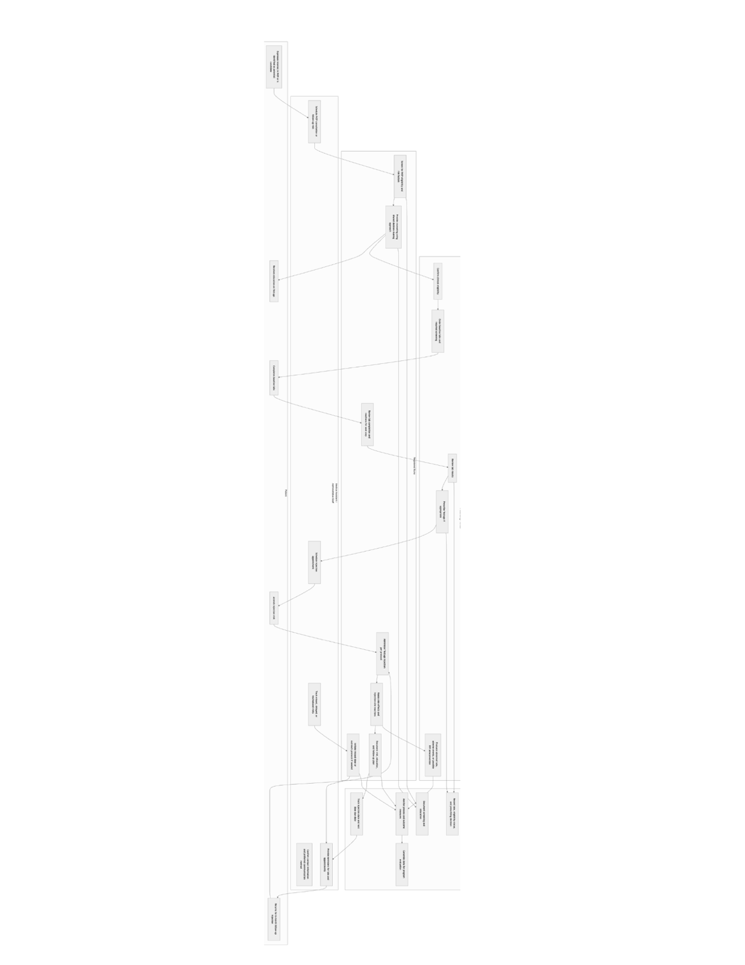
Figure G1.
Clinic Workflow
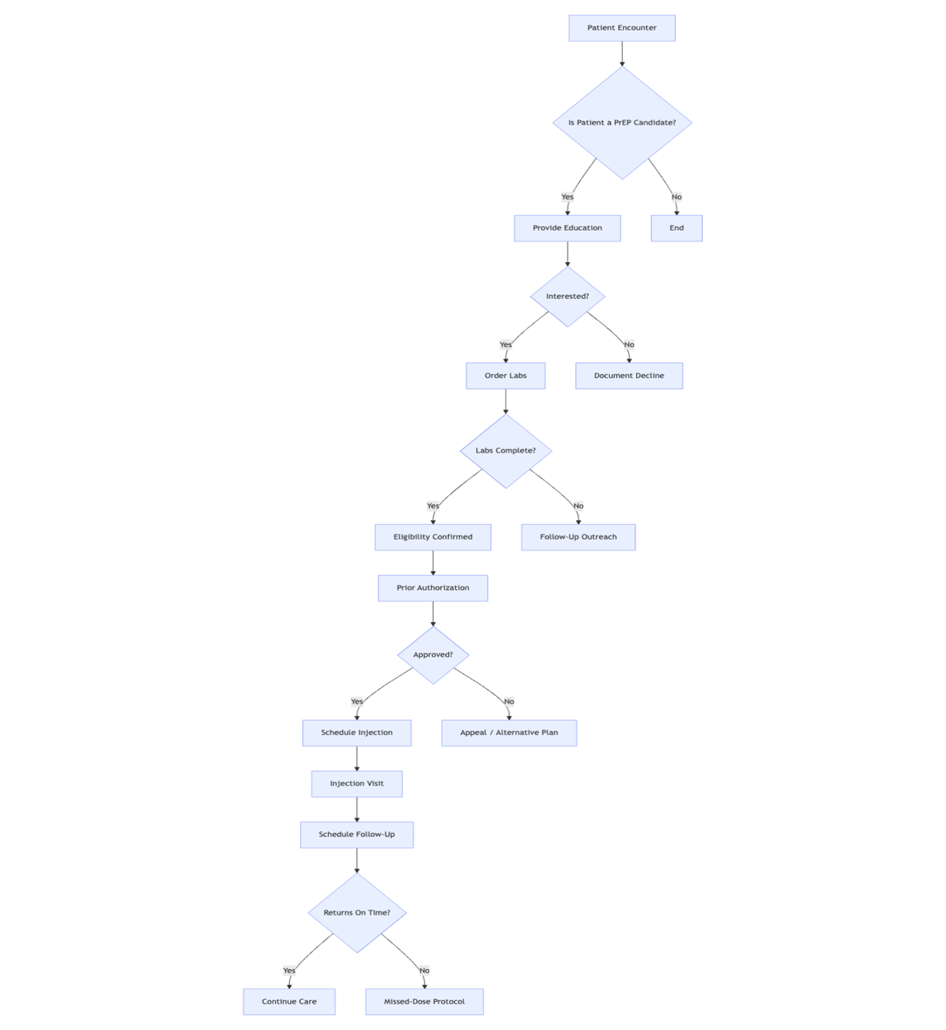

Figure G2.
Clinical Decision Algorithm
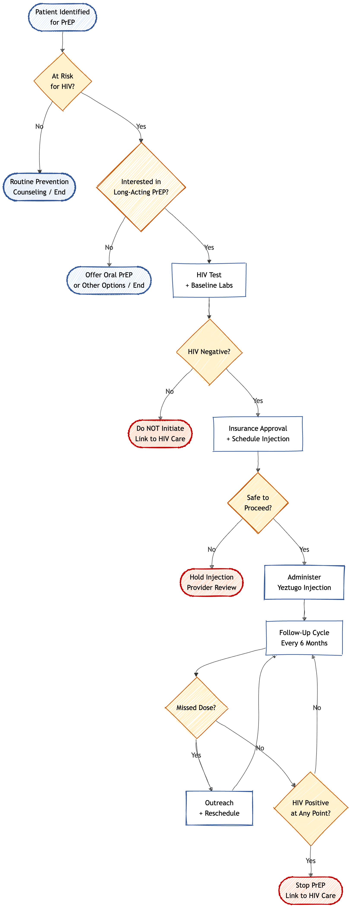

Note. This algorithm outlines the clinical decision-making pathway for identifying eligible patients, initiating Yeztugo (lenacapavir) PrEP, and managing follow-up care, including safety checkpoints for HIV testing, missed doses, and seroconversion.

